Comparative Performance Evaluation of Llama 3, Phi-3, and Qwen 3 in a Retrieval-Augmented Generation Chatbot for the 2024 ESC Atrial Fibrillation Guidelines

Carl Emmanuel M. Macabales
School of Information Technology
Mapùa University
Makati, Philippines
cemmacabales@mymail.mapua.edu.ph
Rolando R. Magat III
School of Information Technology
Mapùa University
Makati, Philippines
rrmagat@mymail.mapua.edu.ph
Yñikko Arzee Neo D. Aguas
School of Information Technology
Mapùa University
Makati, Philippines
yandaguas@mymail.mapua.edu.ph

Abstract—Atrial fibrillation (AF) remains the most prevalent sustained cardiac arrhythmia worldwide, and the complexity of its clinical management, as codified in the 2024 European Society of Cardiology (ESC) Guidelines, poses significant challenges for efficient knowledge retrieval by clinicians and researchers. This paper presents the design, implementation, and comparative evaluation of a Retrieval-Augmented Generation (RAG) chatbot system grounded exclusively in the 2024 ESC AF Guidelines to support accurate, evidence-based question answering. Three open-source instruction-tuned language models are benchmarked within a unified RAG pipeline: Meta's Llama 3 (8B), Microsoft's Phi-3 Mini (3.8B), and Alibaba's Qwen3 (4B), all deployed under 4-bit NF4 quantization for GPU-efficient inference. The retrieval pipeline employs MedCPT biomedical embeddings with FAISS vector indexing and a BGE cross-encoder reranker to maximize retrieval precision. System performance is evaluated across 20 domain-specific clinical queries using a multi-dimensional framework encompassing lexical metrics (ROUGE), semantic metrics (BERTScore, cosine similarity), and LLM-as-judge RAG metrics (Faithfulness, Answer Relevancy, Context Recall). Results demonstrate that Llama 3 achieves the strongest lexical and semantic alignment, recording the highest ROUGE-1 (0.4564), and Semantic Similarity (0.6647), alongside a BERTScore F1 of 0.8351. Phi-3 leads on Faithfulness (8.75/10), making it the most reliable backbone for safety-critical deployments, while Qwen3 delivers the highest throughput at 7.90 tokens/sec with a competitive BERTScore F1 of 0.8187. Despite strong overall performance, a clinically significant hallucination in Qwen3, incorrectly attributing dronedarone over SGLT2 inhibitors for heart failure management, and universal failure on figure-embedded content highlight the continued challenges of precise clinical evidence grounding in text-based RAG pipelines. The system is deployed as an interactive web application via Gradio, demonstrating practical accessibility without dedicated cloud infrastructure. This work provides a reproducible benchmarking framework and empirical guidance for model selection in clinical natural language processing applications.
Keywords — Atrial Fibrillation, Retrieval-Augmented Generation, Large Language Models, Clinical Decision Support, ESC Guidelines, MedCPT, FAISS, BERTScore, LLM Evaluation, Llama 3, Phi-3, Qwen3

INTRODUCTION
Atrial fibrillation (AF) is the most common sustained cardiac arrhythmia worldwide, affecting an estimated 37.5 million people globally and representing a leading cause of stroke, heart failure, and cardiovascular mortality [1]. The clinical management of AF is not only complex and multifaceted but also continuously evolving, as reflected in the 2024 European Society of Cardiology (ESC) Guidelines for the Management of Atrial Fibrillation — a comprehensive clinical reference spanning over 100 pages of evidence-based recommendations, classification frameworks, and treatment algorithms [2]. Among the most clinically consequential updates in this edition are the introduction of the AF-CARE framework and the revised CHA₂DS₂-VA scoring system, which removed the female sex modifier from anticoagulation decision thresholds. For clinicians, students, and researchers, efficiently retrieving precise and contextually accurate information from such a dense, frequently updated document remains a significant practical challenge.
The emergence of Large Language Models (LLMs) has opened new possibilities for automated question answering and knowledge retrieval in specialized domains. However, standalone LLMs are known to suffer from hallucination — generating plausible but factually incorrect responses — particularly on highly specific or technical subject matter [3]. In clinical settings, this is not merely a linguistic concern but a potential patient safety issue: miscalculated anticoagulation thresholds, incorrect dosage recommendations, or fabricated guideline citations can directly compromise patient outcomes [7]. Retrieval-Augmented Generation (RAG) addresses this limitation by grounding model responses in externally retrieved documents, constraining generation to verified source material [4]. RAG architectures have shown considerable promise in biomedical and clinical settings, where factual accuracy and source traceability are paramount [5], [6].
However, the reliability of a RAG system is not solely determined by the quality of its generative backbone — it is equally dependent on the precision of its retrieval component. General-purpose embedding models frequently fail to capture the nuanced semantics of medical terminology, producing retrievals that are semantically plausible but clinically incorrect [8], [10]. Furthermore, architectural challenges such as the "lost-in-the-middle" phenomenon, where LLMs underutilize evidence positioned in the center of long context windows, continue to limit effective evidence integration. Two-stage retrieval pipelines that combine vector similarity search with cross-encoder reranking have been proposed to mitigate this, reducing hallucination risk and improving factual alignment [10], [14]. These considerations directly motivate the retrieval architecture adopted in this study, which employs MedCPT biomedical embeddings for domain-specific vector indexing via FAISS, followed by a BGE cross-encoder reranker to refine candidate passages prior to generation.
Beyond retrieval design, the selection of an appropriate LLM backbone is a critical decision that governs the system's reasoning capability, instruction-following behavior, response latency, and computational efficiency. Recent studies demonstrate that smaller language models trained on high-quality curated datasets can achieve competitive performance in specialized medical question answering [9], making them viable candidates for resource-constrained clinical deployments where GPU memory, latency, and data privacy impose strict operational constraints [15], [16]. To empirically characterize these trade-offs, this study evaluates three open-source instruction-tuned models within the same retrieval pipeline: Meta's Llama 3 (8B parameters, Meta-Llama-3-8B-Instruct), Microsoft's Phi-3 Mini (3.8B parameters, Phi-3-mini-4k-instruct), and Alibaba's Qwen3 (4B parameters, Qwen3-4B-Instruct), all deployed under 4-bit NF4 quantization via BitsAndBytes for GPU-efficient inference. While Llama 3 and Phi-3 apply a chunk size of 1,000 tokens with 150-token overlap, Qwen3 uses a more granular segmentation of 512 tokens with 64-token overlap, allowing a controlled examination of how document segmentation affects retrieval precision and response quality.
Evaluation methodologies for RAG systems have likewise evolved beyond traditional lexical overlap metrics. Multi-dimensional frameworks now assess faithfulness, answer relevance, and context recall as core determinants of clinical utility [12], [14]. Accordingly, this study employs a comprehensive evaluation framework encompassing lexical metrics ( ROUGE), semantic metrics (BERTScore F1, cosine similarity), and LLM-as-judge RAG metrics (Faithfulness, Answer Relevancy, Context Recall), applied across 20 domain-specific clinical queries derived from the ESC guidelines. The results reveal a consistent precision-faithfulness trade-off across the three models: Llama 3 achieves the strongest lexical and semantic alignment, Phi-3 leads on faithfulness — making it the most suitable backbone for safety-critical deployments — and Qwen3 offers the fastest generation throughput, with a competitive overall profile. A clinically significant hallucination produced by Qwen3 at one query, and universal failure on figure-embedded content across all models, further underscore that retrieval precision alone does not guarantee generation fidelity, and that multimodal document parsing remains an open challenge for text-based RAG pipelines [7].
The primary contributions of this work are as follows: (1) a fully functional, end-to-end RAG chatbot grounded exclusively in the 2024 ESC Atrial Fibrillation Guidelines; (2) a reproducible multi-metric benchmarking framework for evaluating open-source LLMs in domain-specific clinical question answering; and (3) empirical evidence on the performance trade-offs among Llama 3, Phi-3 Mini, and Qwen3 under identical retrieval and evaluation conditions, offering practical guidance for backbone selection in clinical natural language processing applications. The system is deployed as an interactive web application via Gradio on a Google Colab environment provisioned with an NVIDIA T4 GPU, demonstrating practical accessibility without requiring dedicated cloud infrastructure.

Related works
Several studies have explored the use of Retrieval-Augmented Generation (RAG) architectures and Large Language Models (LLMs) for clinical question answering and medical natural language processing. Traditional approaches often rely on fine-tuning alone, which limits adaptability to specialized domain knowledge without extensive retraining. Recent advancements in NLP have enabled the development of sophisticated models that integrate retrieval and generation techniques, enhancing both factual grounding and response coherence.
[16] and [28] highlighted the use of instruction-tuned Llama architectures in medical question answering, demonstrating how parameter-efficient fine-tuning and prompting strategies such as ensemble refinement and chain-of-thought reasoning can improve performance on knowledge-intensive benchmarks while remaining competitive with models of significantly larger scale. Similarly, [15] and [27] applied compact language models to clinical domains, with [27] notably concluding that carefully fine-tuned small language models can achieve clinically relevant accuracy at a fraction of the computational cost, though RAG failed to yield consistent gains due to context-window limitations inherent to sub-5B parameter models. [29] demonstrated the potential of two-stage LoRA training combined with weighted adapter merging to balance domain knowledge injection with instruction-following alignment in medical LLMs. [11] further established the Qwen model family as a competitive open-weight alternative across multilingual reasoning and instruction-following benchmarks.
These studies underscore the growing interest in applying RAG-based architectures and efficient language models across clinical and specialized domains. This study builds upon existing research by focusing on the comparative evaluation of Llama-3-8B-Instruct, Phi-3-mini-Instruct, and Qwen3-Instruct within a unified RAG pipeline grounded in the 2024 ESC Guidelines for Atrial Fibrillation, using MedCPT biomedical embeddings and BGE cross-encoder reranking to ensure contextually accurate and faithful clinical responses.

Methodology

A. Dataset Preparation
The knowledge corpus used in this study is the 2024 European Society of Cardiology (ESC) Guidelines for the Management of Atrial Fibrillation, a comprehensive clinical reference document collaboratively developed with the European Association for Cardio-Thoracic Surgery (EACTS) [2]. The document was obtained in PDF format and serves as the sole knowledge base for the proposed RAG-based chatbot system. Given the document's length and technical density, careful preprocessing was essential to ensure efficient retrieval and accurate response generation.
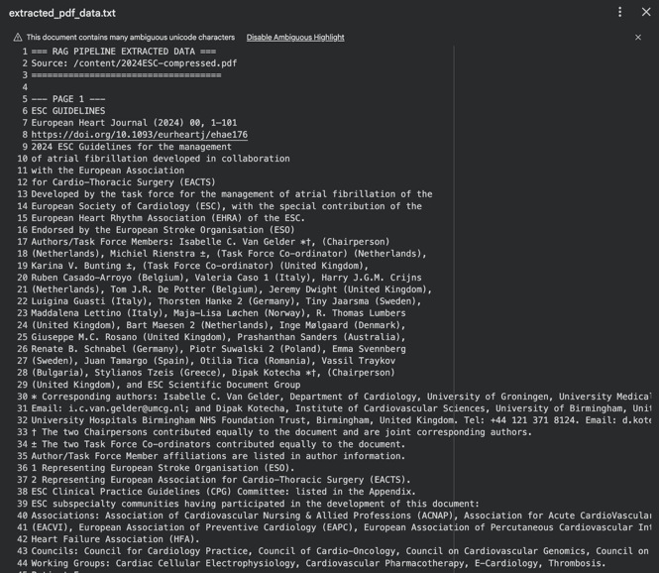
Figure 1. Extracted Text using pdfplumber
The PDF was loaded and processed using pdfplumber, a Python library capable of extracting structured text from complex, multi-column medical documents while preserving page-level metadata (See Figure 1) [18]. Each extracted page was stored as an individual LangChain Document object, retaining its source page number to enable traceable citation during retrieval. This page-aware storage approach ensures that retrieved content can be attributed to specific sections of the guideline, which is critical for clinical accuracy and transparency.
Prior to indexing, the extracted text was split into smaller, overlapping chunks using LangChain's RecursiveCharacterTextSplitter [19]. For the Llama 3 and Phi-3 models, a chunk size of 1,000 tokens with an overlap of 150 tokens was applied, while the Qwen3 configuration used a more granular segmentation of 512 tokens with a 64-token overlap. The overlapping strategy preserves contextual continuity across chunk boundaries, reducing the risk of incomplete or fragmented information being passed to the generation model. The processed chunks were subsequently converted into dense vector embeddings and stored in a FAISS vector index for efficient similarity-based retrieval.
B. Chatbot Architecture
Figure 2 shows the system follows a Retrieval-Augmented Generation (RAG) architecture that integrates document preprocessing, semantic embedding, vector-based retrieval, reranking, and LLM-based response generation into a unified pipeline. The system was implemented in Python using Google Colab with GPU acceleration (T4), and all three models were evaluated under the same retrieval infrastructure to ensure a fair and controlled comparison.

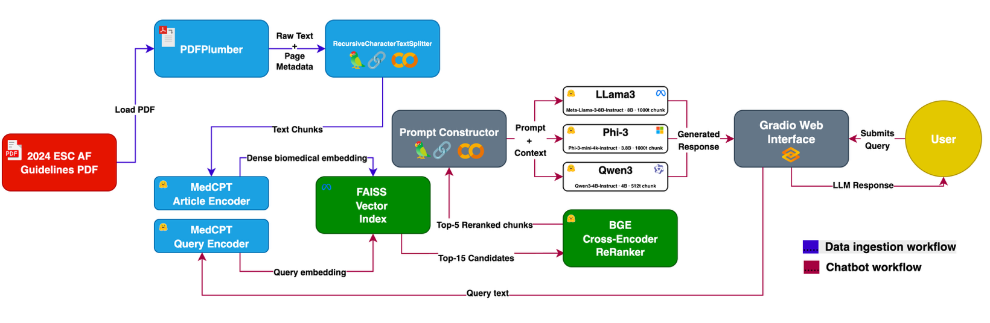
Figure 2. Chatbot Architecture

Embedding and Vector Indexing. Textual chunks produced during preprocessing were encoded into dense vector representations using MedCPT (Medical Contrastive Pre-Training), a biomedical-domain embedding model developed specifically for clinical and scientific text retrieval [20]. MedCPT was selected over general-purpose embedding models due to its ability to capture domain-specific semantic relationships present in medical guidelines. The resulting embeddings were stored and indexed using FAISS (Facebook AI Similarity Search), a high-performance library optimized for efficient nearest-neighbor search over large vector collections [21].
Retrieval and Reranking. Upon receiving a user query, the system converts the query into an embedding using the same MedCPT model and performs a similarity search against the FAISS index, retrieving the top 15 candidate document chunks. To further refine retrieval quality, a BGE cross-encoder reranker (BAAI/bge-reranker-base) is applied to re-score the retrieved candidates based on their semantic relevance to the query. The top 5 chunks following reranking are concatenated to form the context window passed to the generation model. This two-stage retrieval strategy, combining vector similarity search with cross-encoder reranking, improves precision by ensuring that only the most contextually relevant passages inform the generated response.
Response Generation. Three instruction-tuned LLMs are evaluated as generation backends within the same pipeline: (1) Meta's Llama 3 (Meta-Llama-3-8B-Instruct, 8B parameters), (2) Microsoft's Phi-3 Mini (Phi-3-mini-4k-instruct, 3.8B parameters), and (3) Alibaba's Qwen3 (Qwen3-4B-Instruct, 4B parameters). All three models are loaded under 4-bit NF4 quantization using the BitsAndBytes library to reduce GPU memory consumption while preserving inference quality [22]. Each model receives a structured prompt containing the retrieved context and the user's query, and is instructed to generate a response grounded exclusively in the provided document content. This grounding constraint is enforced through prompt engineering to minimize the risk of hallucination.
C. Evaluation Metrics
$$BERTScore-P = \left(\frac{1}{\left|ŷ\right|}\right)· Σ\max{\cos\left(e_{ŷᵢ}, e_{yⱼ}\right)}$$
Eq (1). BERTScore
BERTScore is the primary semantic evaluation metric in this study because it is robust to paraphrasing — a critical property in clinical NLP where equivalent clinical concepts may be expressed with different but equally valid terminology (e.g., "myocardial infarction" vs. "heart attack"). A high BERTScore F1 indicates that the generated response conveys semantically equivalent information to the reference, even when surface phrasing differs [23]. This makes it especially valuable for distinguishing genuine semantic competence from mere surface-level lexical matching.

$$ROUGE_{n}=\frac{Σ count_{match\left(gram_{n}\right)}}{Σ count\left({gram}_{n}, Reference\right)}$$
Eq (2). ROUGE-N
ROUGE focuses on recall rather than precision, making it particularly suited to evaluating whether the generated response covers all the key points present in the reference answer. ROUGE-L is especially informative in clinical NLP because it captures sentence-level structural alignment through the longest shared subsequence, rewarding responses that preserve the logical flow and phrasing of the guideline text even when exact n-gram matches are absent [24].

$$Similarity\left(Q, A\right)=\frac{\left(E_{Q}· E_{A}\right)}{ \left|\left|E_{Q}\right|\right|· \left|\left|E_{A}\right|\right|}$$
Eq (3). Semantic Similarity
This metric captures global meaning alignment at the sentence level, going beyond individual token semantics to assess whether the overall response conveys the same meaning as the reference [25]. A similarity score above 0.70 is used as the minimum threshold for acceptable semantic alignment in this study, consistent with established practice in RAG evaluation literature. Semantic similarity is particularly informative for longer, multi-part answers where BERTScore may overestimate quality due to partial token-level matches across an extended response.

Metric | Significance
Faithfulness | Detects hallucination; critical for clinical safety.
Answer Relevancy | Ensures responses are on-topic and query-focused.
Context Recall | Measures retrieval pipeline effectiveness.
Table 1. RAG/10 Metrics
The three metrics in Table 1 are specific to the retrieval-augmented generation paradigm and are evaluated using an automated LLM-based judge on a 0–10 scale. They assess dimensions of quality that lexical and semantic metrics cannot capture specifically, the grounding, relevance, and retrieval completeness of the system's outputs.
Faithfulness is the most safety-critical metric in clinical NLP applications. A low faithfulness score indicates hallucination — the model has generated content that is not grounded in the retrieved source material, which in clinical settings can mean providing incorrect dosages, wrong classification thresholds, or fabricated guideline recommendations [25]. Monitoring faithfulness is therefore essential to ensure that the RAG system functions as a reliable, evidence-grounded tool rather than a generative system prone to fabrication.
Answer Relevancy is critical for user experience and practical utility, particularly in educational and clinical support applications where students or clinicians require direct, actionable answers rather than broadly informative but unfocused responses. This metric captures a quality dimension that lexical metrics fundamentally miss: a response may share many tokens with the reference yet still fail to address the question if the overlap is incidental [25].
Context Recall is a diagnostic metric for the retrieval component of the RAG pipeline. A low Context Recall score indicates that the retrieval system failed to surface the relevant document sections — meaning that even a perfect generative model would be unable to produce the correct answer, as the necessary information was never provided [25]. Tracking Context Recall separately from Faithfulness and Answer Relevancy allows retrieval failures to be distinguished from generation failures, enabling targeted optimisation of each pipeline component.

D. Web Deployment

To facilitate practical accessibility and real-world evaluation of the proposed RAG pipeline, the system was deployed as an interactive web application using Gradio, a Python-based open-source framework designed for rapid prototyping of machine learning interfaces [26]. Gradio was selected over alternative frameworks such as Streamlit due to its native support for long-running inference tasks, built-in file upload handling, and its ability to generate a publicly accessible URL via its built-in tunneling mechanism, requiring no dedicated server infrastructure or additional configuration. See Figures 5, 6, 7

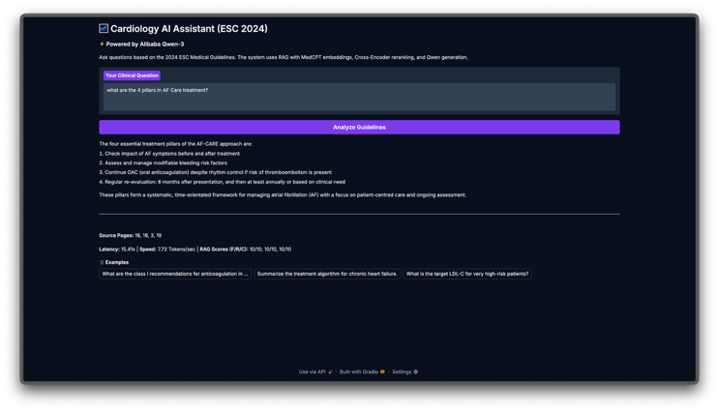
Figure 3. Web Deployment Qwen
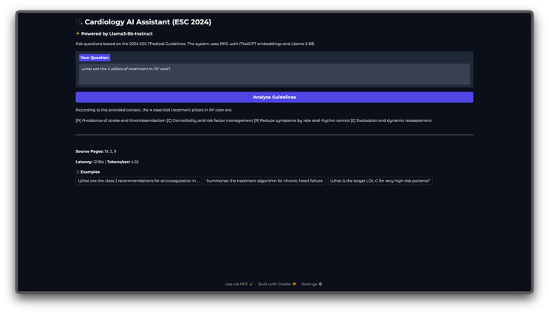
Figure 4. Web Deployment Llama
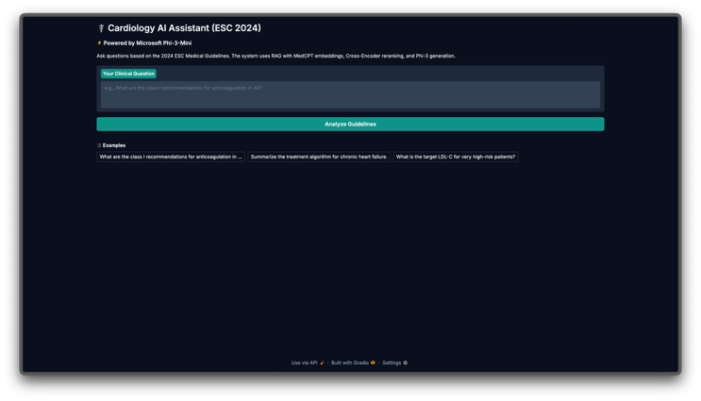
Figure 5. Web Deployment Phi
The application was hosted on a Google Colab environment provisioned with an NVIDIA T4 GPU (15 GB VRAM), which provided sufficient computational resources to load and serve each of the three quantized language models: Meta-Llama-3-8B-Instruct, Microsoft Phi-3-Mini-4K-Instruct, and Qwen3-4B-Instruct. All models were loaded using 4-bit NormalFloat (NF4) quantization via the BitsAndBytes library [22], significantly reducing memory requirements while preserving generation quality. The FAISS vector index, constructed from the 2024 ESC Guidelines for the Management of Atrial Fibrillation using the MedCPT domain-specific embeddings [21] [2] [20], is built once and persisted to disk, allowing it to be reloaded across model switches without recomputation.
The web interface exposes the full RAG pipeline to end users through three core functionalities: (1) dynamic model selection, enabling real-time switching between the three evaluated LLMs within a single session; (2) PDF ingestion, allowing users to upload domain-specific clinical documents for indexing and retrieval; and (3) an optional evaluation panel that computes and displays the complete set of metrics discussed in Section IV, including, ROUGE, BERTScore, cosine semantic similarity, and LLM-as-judge scores for Faithfulness, Answer Relevancy, and Context Recall, when a ground-truth reference answer is provided. This deployment configuration demonstrates that the proposed system can be operationalized in a low-cost, accessible manner without requiring dedicated cloud infrastructure, making it suitable for clinical research and educational settings.

Results

Chatbot Testing Results
The evaluation was conducted using 20 curated queries drawn from the ESC 2024 Atrial Fibrillation (AF) clinical guideline. Each query was posed to all three model variants — LLaMA 3, Qwen 3, and Phi-3 — deployed under identical RAG pipeline configurations. Chatbot responses were assessed against expert-curated expected answers using automated lexical and semantic metrics, as well as LLM-evaluated RAG-quality dimensions. Table I presents a representative sample of 6 queries, comparing the responses generated by each model against the expected ground truth answer.
Overall, the chatbot performed well on factual, policy-grounded queries. Most responses across all three models closely aligned with the expected answers, particularly for definitional queries (e.g., Q19 — Permanent AF definition) and recommendation-class questions with explicit guideline language (e.g., Q7 — VKA INR/TTR target; Q11 — heart rhythm assessment). All three models correctly identified that antiplatelet therapy is not recommended as an alternative to OAC (Q5) and consistently retrieved the correct weight loss target for obese AF patients (Q15).
Notable divergence was observed at Q12, where Qwen 3 incorrectly responded with "Dronedarone" as the heart failure medication recommended regardless of LVEF, while both LLaMA 3 and Phi-3 correctly identified SGLT2 inhibitors. This represents a hallucination event — Qwen retrieved a passage about dronedarone from a nearby guideline section and generated a clinically incorrect response despite the correct information being present in the document. Q17 (AF symptoms in Figure 1) produced weak responses across all three models, as the expected answer contains a visual enumeration embedded in a figure that the text-based RAG pipeline could not fully parse. (Refer to Table 2)

Q | Query | Expected Answer | LLaMA 3 Response | Qwen 3 Response | Phi-3 Response
Q1 | What are the four essential treatment pillars of the AF-CARE framework? | [C] Comorbidity and risk factor management, [A] Avoid stroke and thromboembolism, [R] Reduce symptoms by rate and rhythm control, [E] Evaluation and dynamic reassessment. | [A] Avoidance of stroke and thromboembolism; [R] Reduce symptoms by rate and rhythm control; [E] Evaluation and dynamic reassessment; [C] Comorbidity and risk factor management. | The four essential treatment pillars: (1) Comorbidity and risk factor management; (2) Avoid stroke and thromboembolism; (3) Reduce symptoms by rate and rhythm control; (4) Evaluation and dynamic reassessment. | Diagnostic evaluation of new AF; Education for patients and healthcare professionals; Access to patient-centered management; Management of comorbidity and risk factor.
Q5 | Is antiplatelet therapy recommended as an alternative to OAC for stroke prevention in AF? | No, antiplatelet drugs alone (aspirin or clopidogrel) are not recommended for stroke prevention in AF. | No. Antiplatelet therapy is not recommended as an alternative to OAC for stroke prevention in AF. Antiplatelet drugs such as aspirin and clopidogrel are not an alternative to OAC. | No. Antiplatelet therapy is not recommended as an alternative to OAC for stroke prevention in AF. Adding antiplatelet treatment to OAC is also not recommended for this goal. | No. Antiplatelet therapy is not recommended as an alternative to OAC for stroke prevention in AF. The guidelines do not recommend antiplatelet agents for recurrent embolic stroke either.
Q12 | Which heart failure medication is recommended for AF patients regardless of LVEF? | Sodium-glucose cotransporter-2 (SGLT2) inhibitors. | Sodium-glucose cotransporter-2 (SGLT2) inhibitors are recommended for patients with HF and AF regardless of LVEF to reduce the risk of HF hospitalization and cardiovascular death. | Dronedarone is recommended in patients with AF requiring long-term rhythm control, including those with HFmrEF and HFpEF, irrespective of LVEF. | Sodium-glucose cotransporter-2 inhibitors are recommended for patients with HF and AF regardless of LVEF to reduce the risk of HF hospitalization and cardiovascular death.
Q13 | What should be done if a left atrial thrombus is detected prior to a planned cardioversion? | Therapeutic anticoagulation should be instituted for a minimum of 4 weeks, followed by a repeat TOE to ensure resolution. | Therapeutic anticoagulation should be instituted for a minimum of 4 weeks followed by repeat TOE to ensure thrombus resolution. | Therapeutic anticoagulation should be initiated and repeat transoesophageal echocardiography should be considered. At least 3 weeks of therapeutic OAC (adherence to DOACs or INR ≥2.0) before cardioversion. | A left atrial thrombus is a contraindication to cardioversion. OAC should be given until thrombus is cleared. TOE monitoring during this period is advised before rescheduling the procedure.
Q15 | What is the recommended weight loss target for obese individuals with AF? | A target of 10% or more reduction in body weight. | The recommended weight loss target for obese individuals with AF is a reduction of 10% or more in body weight. | The recommended weight loss target for obese individuals with AF is a 10% or more reduction in body weight. | The recommended weight loss target for obese individuals with AF is a 10% or more reduction in body weight.
Q20 | For patients undergoing cardiac surgery, when is surgical closure of the LAA recommended? | As an adjunct to oral anticoagulation in patients with AF undergoing cardiac surgery to prevent stroke. | Surgical closure of the LAA is recommended as an adjunct to OAC in AF patients undergoing cardiac surgery to prevent ischaemic stroke and thromboembolism. | Surgical closure of the LAA is recommended for stroke prevention in AF patients undergoing cardiac surgery. The procedure is advised as an adjunct to oral anticoagulation. | Surgical closure of the LAA is recommended as an adjunct to OAC in AF patients undergoing cardiac surgery to prevent ischaemic stroke and thromboembolism.
Table 2. Chatbot Testing Results - Sample Query Samples (6 of 20)

Evaluation Scores Per Query

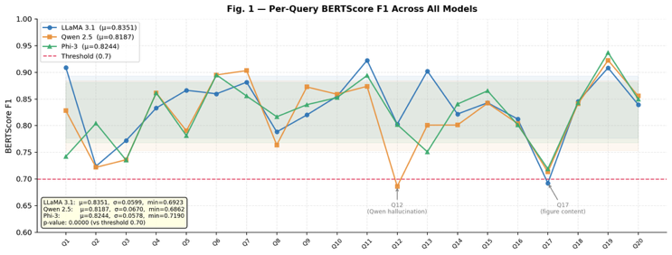
Figure 6. Per-Query BERTScore F1 Across All Models

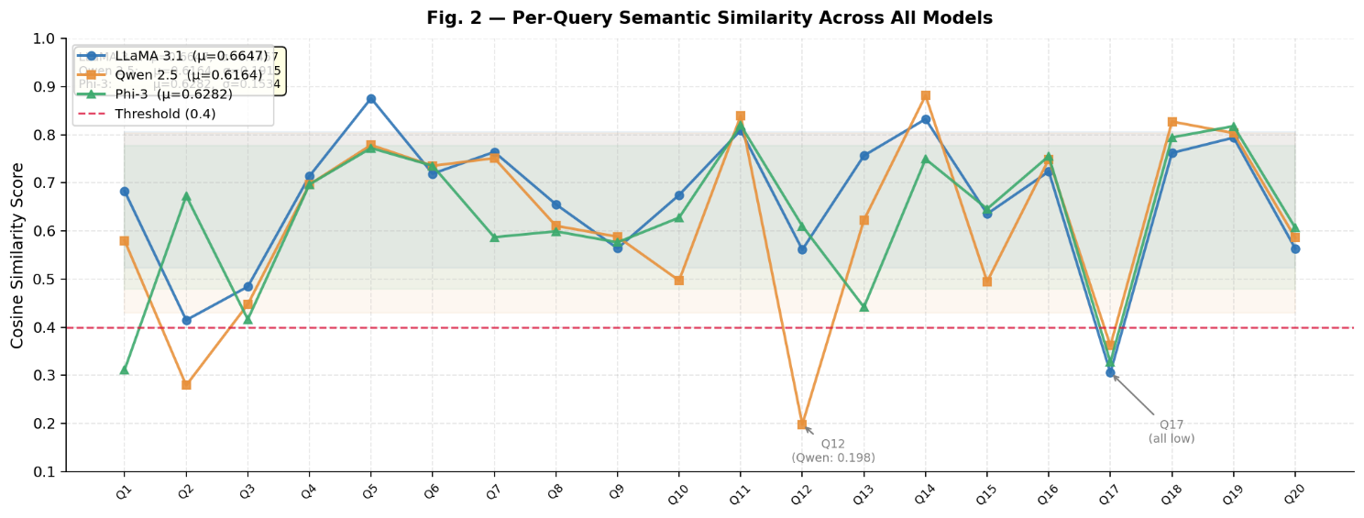
Figure 7. Per-Query Semantic Similarity Across All Models

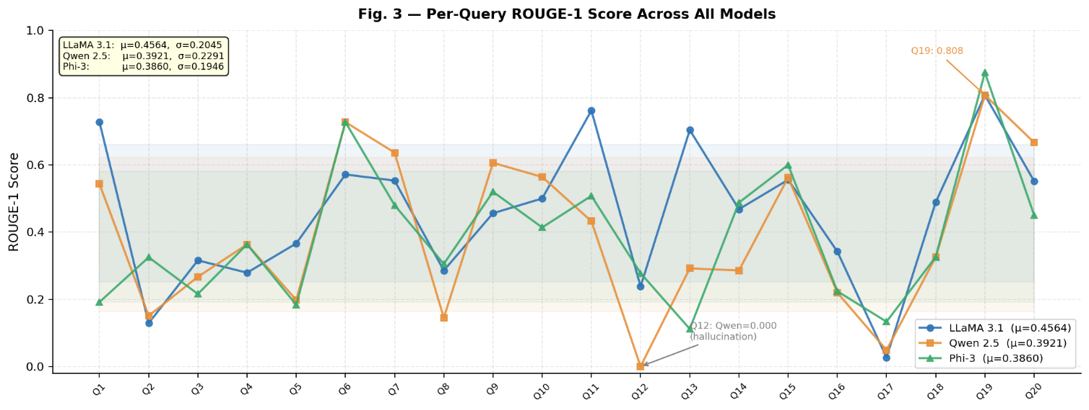
Figure 8. Per-Query ROUGE-1 Score Across All Models
Figure 6, 7, 8 reports per-query BERTScore F1, Semantic Similarity, and ROUGE-1 for all 20 test queries across the three models. BERTScore F1 uses contextual embeddings to measure semantic token-level similarity beyond surface matching, making it particularly suited for clinical NLP evaluation where paraphrasing of equivalent clinical concepts is common. Semantic Similarity captures global sentence-level meaning alignment via cosine distance, while ROUGE-1 measures unigram recall.
LLaMA 3 achieves the highest mean BERTScore F1 (0.8351) and Semantic Similarity (0.6647), followed by Phi-3 (0.8244 / 0.6282) and Qwen3 (0.8187 / 0.6164). The narrow BERTScore gap across models (less than 0.02 between LLaMA and Qwen) contrasts with the wider ROUGE-1 gap (0.4564 vs. 0.3921 vs. 0.3860), confirming that all three models produce semantically coherent responses even when surface-level phrasing diverges from the reference. The lowest BERTScore values cluster around Q17 (figure-content query, ~0.69–0.72) and Q12 (Qwen hallucination, 0.6862), while the highest scores appear consistently on Q11, Q7, Q19, and Q1 — queries with unambiguous, text-accessible reference answers.

Statistical Significance of Semantics Scores
Figure 9 presents a summary of the key averaged evaluation metrics for each model. LLaMA 3 consistently achieves the highest scores on lexical precision (ROUGE-1), semantic alignment (Semantic Similarity), and context utilization (Context Recall), while Phi-3 leads on Faithfulness. Averaged across 20 queries, Faithfulness scores were 8.05/10 for Llama 3, 8.75/10 for Phi-3, and 8.50/10 for Qwen3. Answer Relevancy averaged 8.90/10, 8.60/10, and 8.90/10, and Context Recall averaged 9.00/10, 8.50/10, and 8.30/10 for Llama 3, Phi-3, and Qwen3 respectively. Qwen 3 demonstrates a balanced profile with the strongest individual BERTScore F1 on several queries and the highest throughput efficiency (7.90 tokens/sec vs. 4.43 for LLaMA and 5.97 for Phi-3). Faithfulness, Answer Relevancy, and Context Recall are normalized to [0,1] by dividing by 10 for visual comparability.
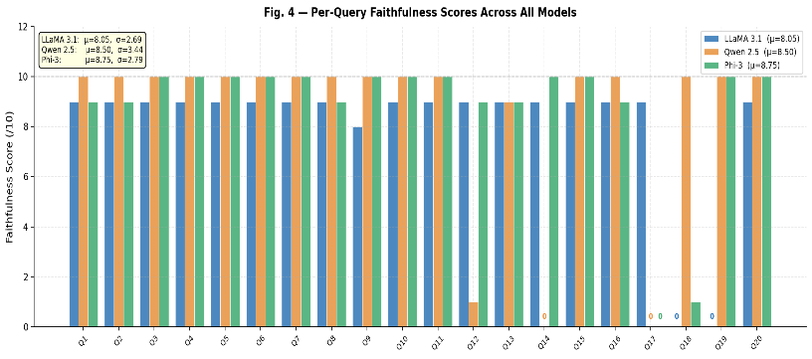
Figure 9. Faithfulness Per-Query Scores Across All Models

Discussion

Performance Trade-Offs Across Models
The evaluation reveals a consistent precision-faithfulness trade-off across the three models that reflects fundamentally different generation philosophies. LLaMA 3 produces responses that most closely match the structure and vocabulary of the reference answers, leveraging both retrieved context and its parametric pre-trained knowledge of clinical cardiology. This results in the highest, ROUGE-1 (0.4564), and Semantic Similarity (0.6647) scores, but comes at the cost of lower Faithfulness (8.05/10) — the model occasionally extends beyond the strictly retrieved content. Phi-3 adopts a more extractive stance, generating responses tightly bounded by retrieved passages, yielding the highest Faithfulness (8.75/10) but lower surface-level alignment with reference answers. Qwen 3 presents a generalist profile with a Faithfulness score of 8.50/10, competitive across all dimensions and fastest in throughput, with the exception of the Q12 hallucination.

Retrieval Limitations and Failure Cases
Two systematic failure patterns emerge from the per-query analysis. First, figure-embedded content (Q17 — AF symptoms listed in Figure 1) is inaccessible to all three models via the text-based RAG pipeline, as the visual enumeration is not captured during PDF text extraction. This results in near-zero ROUGE-1 scores and collapsed Faithfulness/Answer Relevancy for Q17 across all models. Second, Q12 (SGLT2 inhibitors) exposes Qwen 3's susceptibility to retrieval ambiguity: the surrounding context contains competing clinical entities (dronedarone and SGLT2 inhibitors), and Qwen incorrectly selected the former. LLaMA and Phi-3 navigated this ambiguity correctly. These failure modes are not LLM-specific per se but highlight the importance of multimodal document parsing and query-aware reranking as priorities for pipeline improvement.

Clinical NLP Deployment Implications
The results have direct implications for model selection in clinical RAG deployments. LLaMA 3 is best suited for applications where comprehensive, reference-aligned answer coverage is paramount — such as guideline summarization or research-support tools. Phi-3's superior faithfulness makes it the preferred backbone for safety-critical deployments where hallucination risk must be minimized, such as real-time clinical decision support or pharmacological query systems. Qwen 3 offers the most practical balance for interactive educational or patient-facing tools, combining competitive accuracy with the lowest generation latency (10.37 seconds, 7.90 tokens/sec). Future iterations should explore ensemble strategies — for instance, using Phi-3 as a faithfulness verification layer over LLaMA-generated responses — to combine the complementary strengths of each model.

Conclusion and recommendations

This study presented the design, implementation, and comparative evaluation of a Retrieval-Augmented Generation (RAG)-based clinical chatbot grounded in the 2024 ESC Guidelines for the Management of Atrial Fibrillation. Three open-source, instruction-tuned language models, Meta's Llama 3 (8B), Microsoft's Phi-3 Mini (3.8B), and Alibaba's Qwen3 (4B), were systematically benchmarked within a unified retrieval pipeline comprising MedCPT biomedical embeddings, FAISS vector indexing, and BGE cross-encoder reranking, all evaluated under 4-bit NF4 quantization for resource-efficient inference.
Across 20 domain-specific clinical queries, all three models demonstrated competitive performance on factual and policy-grounded questions. Llama 3 achieved the strongest lexical and semantic alignment overall, recording the highest ROUGE-1 (0.4564), Semantic Similarity (0.6647), and BERTScore F1 (0.8351), reflecting its ability to produce reference-aligned, comprehensive responses. Phi-3 demonstrated the highest Faithfulness score (8.75/10), adopting a more extractive generation stance that closely bounds responses to retrieved passages, a critical advantage in safety-sensitive deployments. Qwen3 offered the most balanced operational profile, achieving a competitive BERTScore F1 of 0.8187 and the fastest generation throughput at 7.90 tokens/sec (average response time of 10.37 seconds), making it well-suited for interactive and latency-sensitive applications. The narrow BERTScore gap across all three models (less than 0.02 between Llama 3 and Qwen3) confirms that all backends produce semantically coherent responses even when surface-level phrasing diverges from the reference. The two-stage retrieval pipeline proved effective in surfacing relevant guideline passages, contributing to high context recall and faithfulness scores across most evaluated queries. The system's successful deployment as a Gradio-based web application further validates its practical accessibility in low-resource clinical and educational settings without requiring dedicated server infrastructure.
However, key limitations were identified. Qwen3 produced a clinically significant hallucination at Q12, incorrectly attributing dronedarone as the recommended heart failure pharmacotherapy despite the correct information being present in the retrieved context, underscoring that retrieval precision alone does not guarantee generation fidelity. Additionally, all three models performed poorly on Q17, where the expected answer was embedded within a figure in the source document, a structural limitation inherent to text-based RAG pipelines that cannot parse visual or tabular content. These findings confirm that hallucination in medical RAG systems is not merely a linguistic artifact, but a tangible patient safety concern that demands rigorous mitigation strategies.
Taken together, the results demonstrate that RAG-augmented small language models can serve as viable, computationally accessible tools for clinical guideline question answering, if retrieval quality, prompt grounding constraints, and output validation mechanisms are carefully optimized. No single model dominated across all evaluation dimensions, suggesting that backbone selection should be guided by the specific performance priorities of the deployment context, whether that be factual precision, response latency, or semantic fluency.
Building these findings, several recommendations are proposed for researchers and developers seeking to build or extend RAG-based clinical decision support systems. First, domain-specific embedding models such as MedCPT should be prioritized over general-purpose encoders, as they more effectively capture the nuanced semantic relationships inherent to medical terminology, reducing clinically irrelevant retrievals. Second, a two-stage retrieval architecture combining FAISS-based candidate retrieval with cross-encoder reranking is strongly advised, as vector similarity search alone is insufficient for high-stakes clinical applications. Third, future systems should integrate multimodal document parsing to extract and index content from figures, tables, and flowcharts, elements prevalent in clinical guidelines that text-only pipelines consistently fail to utilize. Fourth, strict grounding constraints should be enforced through prompt engineering, explicitly instructing models to confine responses to retrieved evidence and flag queries where retrieved context is insufficient. Fifth, faithfulness-focused hallucination monitoring should be embedded as a continuous evaluation layer in production deployments, with low-faithfulness outputs flagged for expert review before being surfaced to end users. Finally, future work should conduct controlled ablation studies on chunking strategies and extend benchmarking to larger model variants, such as Llama 3 70B and Qwen3 14B, to more comprehensively characterize the fidelity-efficiency trade-off in clinical RAG systems.

Acknowledgments
The researchers extend their deepest appreciation to Dr. Lysa Comia for her exceptional mentorship and insightful contributions, which greatly enhanced the quality of this study. Her dedication, expertise, and encouragement served as a vital source of inspiration throughout the research process. The team is profoundly grateful for the continuous guidance and support that made this work possible.

References‌
[1] G. Lippi, F. Sanchis-Gomar, and G. Cervellin, "Global epidemiology of atrial fibrillation: An increasing epidemic and public health challenge," Int. J. Stroke, vol. 16, no. 2, pp. 217–221, Feb. 2021, doi: https://doi.org/10.1177/1747493019897870.
[2] A. J. Camm et al., "2024 ESC Guidelines for the management of atrial fibrillation," European Heart Journal, 2024.
[3] J. Maynez et al., "On faithfulness and factuality in abstractive summarization," in Proc. ACL, 2020.
[4] P. Lewis et al., "Retrieval-augmented generation for knowledge-intensive NLP tasks," in Proc. NeurIPS, 2020.
[5] P. Adejumo et al., “Evaluation of Care Quality for Atrial Fibrillation Across Non-Interoperable Electronic Health Record Data using a Retrieval-Augmented Generation-enabled Large Language Model,” medRxiv : the preprint server for health sciences, p. 2024.09.19.24313992, Winter 2025, doi: https://doi.org/10.1101/2024.09.19.24313992.
[6] L. M. Amugongo, P. Mascheroni, S. Brooks, S. Doering, and J. Seidel, “Retrieval augmented generation for large language models in healthcare: A systematic review,” PLOS Digital Health, vol. 4, no. 6, p. e0000877, Jun. 2025, doi: https://doi.org/10.1371/journal.pdig.0000877.
[7] S. Bedi et al., “Testing and Evaluation of Health Care Applications of Large Language Models,” JAMA, Oct. 2024, doi: https://doi.org/10.1001/jama.2024.21700.
[8] H. Kim et al., “Rethinking Retrieval-Augmented Generation for Medicine: A Large-Scale, Systematic Expert Evaluation and Practical Insights,” arXiv.org, 2025. https://arxiv.org/abs/2511.06738
[9] B. Moell, A. F. Sand, and S. Akbar, “Medical Reasoning in LLMs: An In-Depth Analysis of DeepSeek R1,” arXiv.org, 2025. https://arxiv.org/abs/2504.00016
[10] N. T. Ngo, V. Nguyen, F. Dernoncourt, and T. H. Nguyen, “Comprehensive and Practical Evaluation of Retrieval-Augmented Generation Systems for Medical Question Answering,” arXiv.org, 2024. https://arxiv.org/abs/2411.09213
[11]A. Yang et al., “Qwen3 Technical Report,” arXiv.org, 2025. https://arxiv.org/abs/2505.09388
[12]A. Vinayan Kozhipuram, S. Shailendra, and R. Kadel, “Retrieval-Augmented Generation vs. Baseline LLMs: A Multi-Metric Evaluation for Knowledge-Intensive Content,” Information, vol. 16, no. 9, p. 766, Sep. 2025, doi: https://doi.org/10.3390/info16090766.
‌ [13]R. Feng et al., “Engineering of Generative Artificial Intelligence and Natural Language Processing Models to Accurately Identify Arrhythmia Recurrence,” Circulation Arrhythmia and Electrophysiology, Dec. 2024, doi: https://doi.org/10.1161/circep.124.013023.
‌ [14]S. Xu, Z. Yan, C. Dai, and F. Wu, “MEGA-RAG: a retrieval-augmented generation framework with multi-evidence guided answer refinement for mitigating hallucinations of LLMs in public health,” Frontiers in Public Health, vol. 13, Oct. 2025, doi: https://doi.org/10.3389/fpubh.2025.1635381.
[15]M. Abdin et al., “Phi-3 Technical Report: A Highly Capable Language Model Locally on Your Phone,” arXiv.org, Apr. 23, 2024. https://arxiv.org/abs/2404.14219
‌ [16]A. Dubey et al., “The Llama 3 Herd of Models,” arXiv.org, 2024. https://arxiv.org/abs/2407.21783
‌ [17]Bhagyajit Pingua et al., “Medical LLMs: Fine-Tuning vs. Retrieval-Augmented Generation,” Bioengineering, vol. 12, no. 7, pp. 687–687, Jun. 2025, doi: https://doi.org/10.3390/bioengineering12070687.
[18] J. Singer-Vine, "pdfplumber: Plumb a PDF for detailed information about each character, rectangle, line, et cetera — and easily extract text and tables," GitHub, 2023. [Online]. Available: https://github.com/jsvine/pdfplumber
[19] H. Chase, "LangChain," GitHub, 2022. [Online]. Available: https://github.com/langchain-ai/langchain
[20] Q. Jin, W. Kim, Q. Chen, D. Comeau, L. Yeganova, W. J. Wilbur, and Z. Lu, "MedCPT: Contrastive Pre-trained Transformers with large-scale PubMed search logs for zero-shot biomedical information retrieval," Bioinformatics, vol. 39, no. 11, p. btad651, Nov. 2023, doi: https://doi.org/10.1093/bioinformatics/btad651.
[21] M. Douze, A. Guzhva, C. Deng, J. Johnson, G. Szilvasy, P.-E. Mazaré, M. Lomeli, L. Hosseini, and H. Jégou, "The Faiss library," arXiv preprint arXiv:2401.08281, 2024.
[22] T. Dettmers, A. Pagnoni, A. Holtzman, and L. Zettlemoyer, "QLoRA: Efficient finetuning of quantized LLMs," in Proc. Adv. Neural Inf. Process. Syst. (NeurIPS), vol. 36, 2023, doi: https://doi.org/10.48550/arXiv.2305.14314.

[23] T. Zhang, V. Kishore, F. Wu, K. Q. Weinberger, and Y. Artzi, "BERTScore: Evaluating text generation with BERT," in Proc. 8th Int. Conf. Learning Representations (ICLR), Addis Ababa, Ethiopia, Apr. 2020. [Online]. Available: https://openreview.net/forum?id=SkeHuCVFDr
[24] C.-Y. Lin, "ROUGE: A package for automatic evaluation of summaries," in Proc. Workshop Text Summarization Branches Out (ACL 2004 Workshop), Barcelona, Spain, Jul. 2004, pp. 74–81.
[25] S. Es, J. James, L. Espinosa-Anke, and S. Schockaert, "RAGAs: Automated evaluation of retrieval augmented generation," in Proc. 18th Conf. Eur. Chapter Assoc. Comput. Linguistics (EACL): System Demonstrations, St. Julian's, Malta, Mar. 2024, pp. 150–158, doi: https://doi.org/10.18653/v1/2024.eacl-demo.16.
[26] A. Abid, A. Abdalla, A. Abid, D. Khan, A. Alfozan, and J. Zou, "Gradio: Hassle-free sharing and testing of ML models in the wild," arXiv preprint arXiv:1906.02569, Jun. 2019, doi: https://doi.org/10.48550/arXiv.1906.02569.
[27]K. Vishwanath, J. Stryker, A. Alyakin, D. A. Alber, and E. K. Oermann, “MedMobile: a mobile-sized language model with clinical capabilities,” BMJ Digital Health & AI, vol. 1, no. 1, p. e000068, Nov. 2025, doi: https://doi.org/10.1136/bmjdhai-2025-000068.
‌ [28]J. Meribe and S. Zhang, “UltimateMedLLM-Llama3-8B: Fine-tuning Llama 3 for Medical Question-Answering Stanford CS224N Custom Project.” Accessed: Mar. 04, 2026. [Online]. Available: https://web.stanford.edu/class/archive/cs/cs224n/cs224n.1254/final-reports/256847341.pdf
‌ [29]J. Zou and Y. Li, “Medical-Qwen3: A Robust Medical LLM via Two-Stage LoRA Training and Weighted Adapter Merging,” Jan. 2026, doi: https://doi.org/10.36227/techrxiv.176799759.97935754/v1.
‌

